The image below is of updated css file

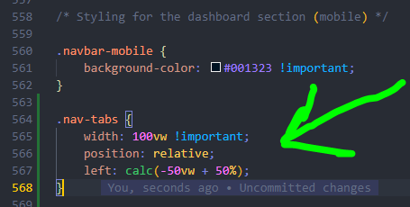

The css file when viewed by inspecting the page source and then navigating to the file
